|  |  |
| --- | --- |
| Course – Section | Computer Networks (CS3001 - Spring 2024) – *BCS 6B* |
| Assignment Num. | 05 |
| Total Marks | 45 |
| Start Date | 20-April-2024 |
| Due Date/Time | 28- April -2024 |
| Submission | ***Submit the handwritten assignment in class as well as google classroom*** |
| Author | Hammad Ali ([l215273@lhr.nu.edu.pk](mailto:l215273@lhr.nu.edu.pk)) |
| Approved By | Ms. Umme Ammarah ([umme.ammarah@lhr.nu.edu.pk](mailto:umme.ammarah@lhr.nu.edu.pk)) |

1. What is the “count to infinity” problem in distance vector routing?

The count-to-infinity problem refers to a problem of distance vector routing. The problem means that it takes a long time for a distance vector routing algorithm to converge when there is a link cost increase. For example, consider a network of three nodes x, y, and z. Suppose initially the link costs are c(x,y)=4, c(x,z)=50, and c(y,z)=1. The result of distance-vector routing algorithm says that z’s path to x is z→y→ x and the cost is 5(=4+1). When the cost of link (x,y) increases from 4 to 60, it will take 44 iterations of running the distance-vector routing algorithm for node z to realize that its new least-cost path to x is via its direct link to x, and hence y will also realize its least-cost path to x is via z.

**(4 marks)**

1. For the figure given below. Compute the shortest path from z to all network nodes using Dijkstra’s algorithm.

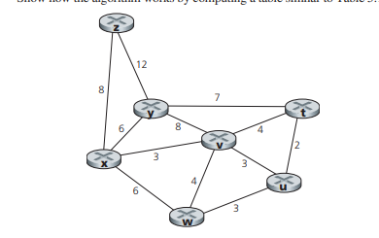

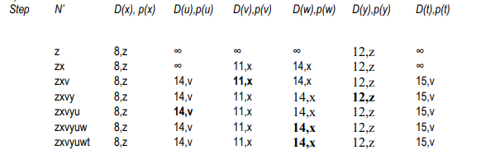

**(6 marks)**

1. Why are different inter-AS and intra-AS protocols used in the Internet?

Policy: Among ASs, policy issues dominate. It may well be important that traffic originating in a given AS not be able to pass through another specific AS. Similarly, a given AS may want to control what transit traffic it carries between other ASs. Within an AS, everything is nominally under the same administrative control and thus policy issues a much less important role in choosing routes with in AS.

Scale: The ability of a routing algorithm and its data structures to scale to handle routing to/among large numbers of networks is a critical issue in inter-AS routing. Within an AS, scalability is less of a concern. For one thing, if a single administrative domain becomes too large, it is always possible to divide it into two ASs and perform inter-AS routing between the two new ASs.

Performance: Because inter-AS routing is so policy oriented, the quality (for example, performance) of the routes used is often of secondary concern (that is, a longer or more costly route that satisfies certain policy criteria may well be taken over a route that is shorter but does not meet that criteria). Indeed, we saw that among ASs, there is not even the notion of cost (other than AS hop count) associated with routes. Within a single AS, however, such policy concerns are of less importance, allowing routing to focus more on the level of performance realized on a route

# (4 marks)

1. Suppose ASs X and Z are not directly connected but instead are connected by AS Y. Further suppose that X has a peering agreement with Y, and that Y has a peering agreement with Z. Finally, suppose that Z wants to transit all of Y’s traffic but does not want to transit X’s traffic. Does BGP allow Z to implement this policy?

Since Z wants to transit Y's traffic, Z will send route advertisements to Y. In this manner, when Y has a datagram that is destined to an IP that can be reached through Z, Y will have the option of sending the datagram through Z. However, if Z advertizes routes to Y, Y can re-advertize those routes to X. Therefore, in this case, there is nothing Z can do from preventing traffic from X to transit through Z

# (6 marks)

# 

1. Names four different types of ICMP messages.

# Echo reply (to ping), type 0, code 0

# Destination network unreachable, type 3 code 0

# Destination host unreachable, type 3, code 1.

# Source quench (congestion control), type 4 code 0.

# (4 marks)

1. Consider the network shown below, and assume that each node initially knows the costs to each of its neighbors. Consider the distance-vector algorithm and show the distance table entries at node z.

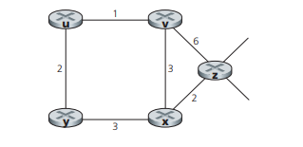

Cost to

u v x y z

v ∞ ∞ ∞ ∞ ∞

From x ∞ ∞ ∞ ∞ ∞

z ∞ 6 2 ∞ 0

Cost to

u v x y z

v 1 0 3 ∞ 6

From x ∞ 3 0 3 2

z 7 5 2 5 0

Cost to

u v x y z

v 1 0 3 3 5

From x 4 3 0 3 2

z 6 5 2 5 0

Cost to

u v x y z

v 1 0 3 3 5

From x 4 3 0 3 2

z 6 5 2 5 0

# (6 marks)

1. Consider the network shown below. Suppose AS3 and AS2 are running OSPF for their intra-AS routing protocol. Suppose AS1 and AS4 are running RIP for their intra-AS routing protocol. Suppose eBGP and iBGP are used for the inter-AS routing protocol. Initially suppose there is no physical link between AS2 and AS4.

a. Router 3c learns about prefix x from which routing protocol: OSPF, RIP, eBGP, or iBGP?

eBGP

b. Router 3a learns about x from which routing protocol?

iBGP

c. Router 1c learns about x from which routing protocol?

eBGP

d. Router 1d learns about x from which routing protocol?

iBGP

# (8 marks)

1. In Following figure, suppose that there is another stub network V that is a customer of ISP A. Suppose that B and C have a peering relationship, and A is a customer of both B and C. Suppose that A would like to have the traffic destined to W to come from B only, and the traffic destined to V from either B or C. How should A advertise its routes to B and C? What AS routes does C receive?

# 

# A should advise to B two routes, AS-paths A-W and A-V.

# A should advise to C only one route, A-V.

# C receives AS paths: B-A-W, B-A-V, A-V.

# (7 marks)

(Good Luck)